Case Study - London Calling!!

# Objective:

Which borough of London has seen the greatest average increase in housing prices over

the (approximately) two decades covered by the dataset?

# Process:

Source Data: <https://data.london.gov.uk/download/uk-house-price-index/70ac0766-8902-4eb5-aab5-01951aaed773/UK%20House%20price%20index.xls>

Data was provided which contained the average home price by month and year for each of the 32 London boroughs as well as the City of London and other regional categories.

The data was provided for January 1995 through September 2021. The objective was to analyze the dates between 1998 and 2018.

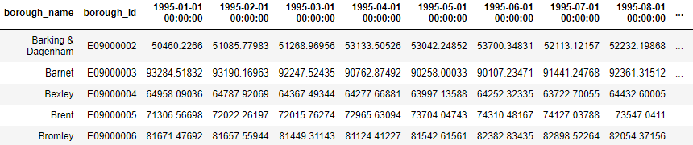

The data was cleaned, organized, and summarized to calculate the price increase ratio between 1998 and 2018 for each of the 32 London boroughs.

# 

# Analysis:

## The following table contains the results of the calculations.

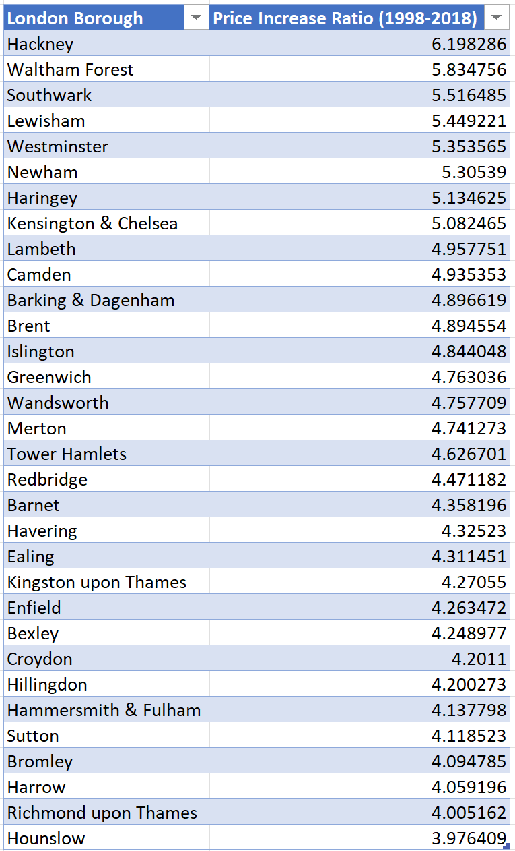

## The chart below depicts the top 10 boroughs based on price increase ratio between 1998 and 2018.

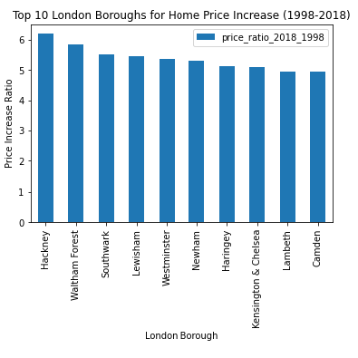

# 

# Conclusions:

* The borough of Hackney had an increase ratio of 6.2 which was the highest of all of the 32 London boroughs. Hackney borders the City of London to the north.
* All of the top 10 boroughs were in close proximity to and surrounding the City of London.
* Two of the boroughs bordering the City of London were not in the top 10 rankings. The boroughs of Islington and Tower Hamlets ranked 13 and 17 respectively. These two boroughs also border the top ranked borough of Hackney.
* One may assume that there was an increased demand versus the supply of properties in the boroughs close to the city over the time period of 1998-2018. However, more data and analysis would be required to determine the root cause of why the boroughs surrounding the city had the largest price increases.
* It would also be interesting to analyze why the bordering boroughs of Islington and Tower Hamlets had lower price increases than Hackney and the other surrounding boroughs.

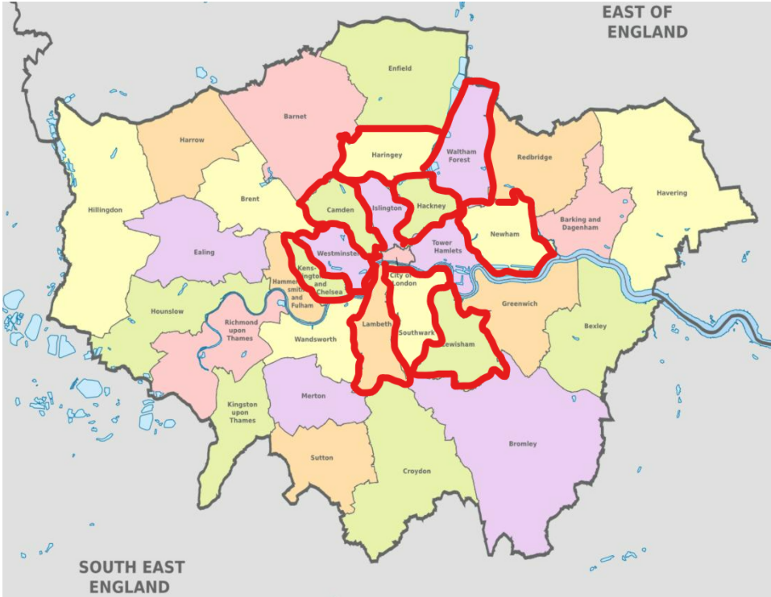

<https://londonmap360.com/london-boroughs-map>